Azure Web App demo lab

On Visual Studio – create a web api

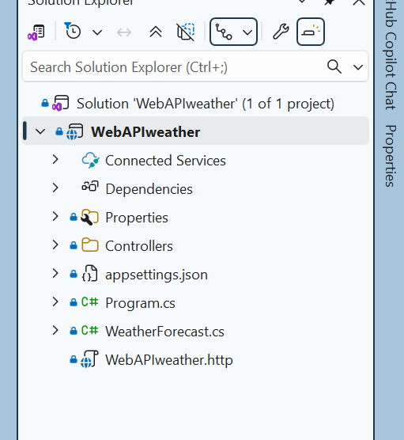
Add to source repo
Select a github account
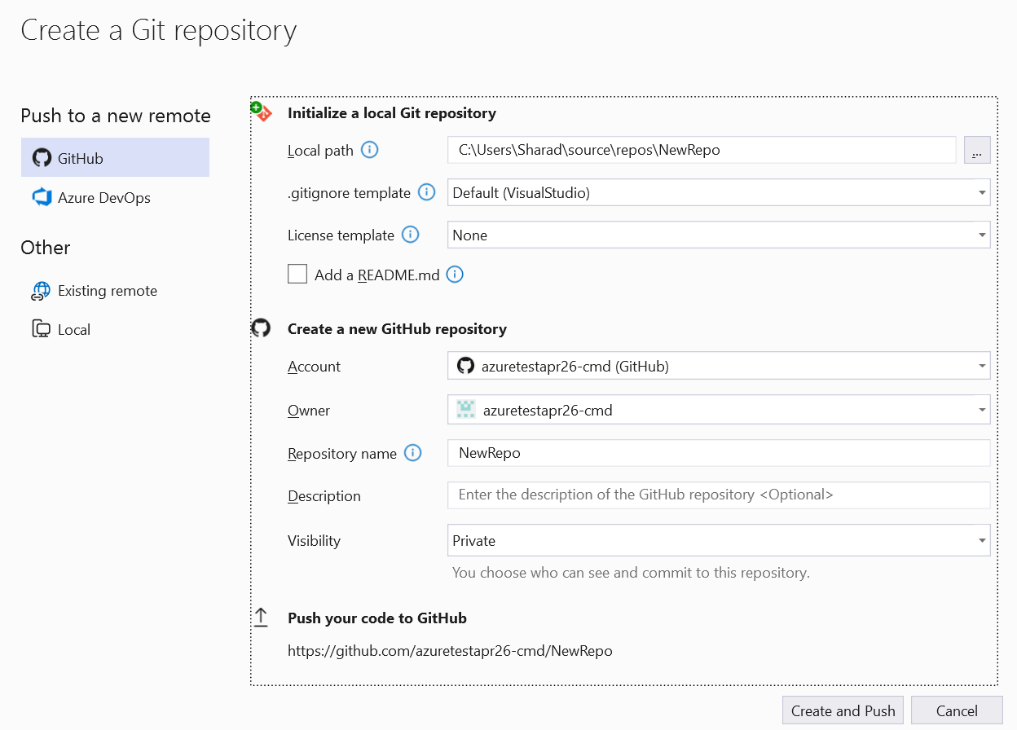

🔶 PART 1: Create Web App
Step 1: Create Resource Group
- Go to Azure Portal → Resource Groups → Create
- Name: rg-webapp-demo
- Region: Central India (or closest)

Step 2: Create Web App
- Go to App Services → Create Web App
- Fill:
Setting | Value
Resource Group | rg-webapp-demo
Name | webappdemo<unique>
Publish | Code
Runtime Stack | .NET 8 / Node.js / PHP
OS | Windows (or Linux)
Region | Same as RG

Step 3: App Service Plan
- Create new:
  - Name: asp-webapp-demo
  - Pricing Tier: B1 (Basic) for demo
👉 Teaching point:
- App Service Plan = compute (CPU/RAM)
- Multiple apps can share one plan

Step 4: Review + Create
- Click Create
- Wait for deployment (~1–2 min)

🔶 PART 2: Test Default App
- Go to resource → Click Browse
- URL:
https://webappdemoXXXX.azurewebsites.net
👉 Teaching point:
- Azure provides default domain
- App is already live (PaaS advantage)

🔶 PART 3: Deploy Sample Application
Option A: Quick Deployment (Recommended for demo)
Using Deployment Center
- Go to Deployment Center
- Source: GitHub
- Repo: sample Node/.NET app
👉 Example repo:
- https://github.com/Azure-Samples/nodejs-docs-hello-world
- Authorize GitHub
- Select repo + branch → Save
✔ Auto deployment starts

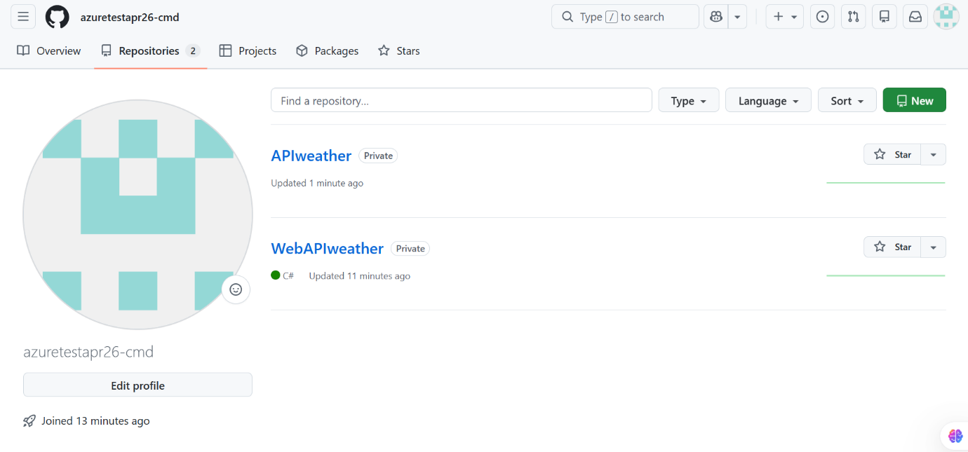

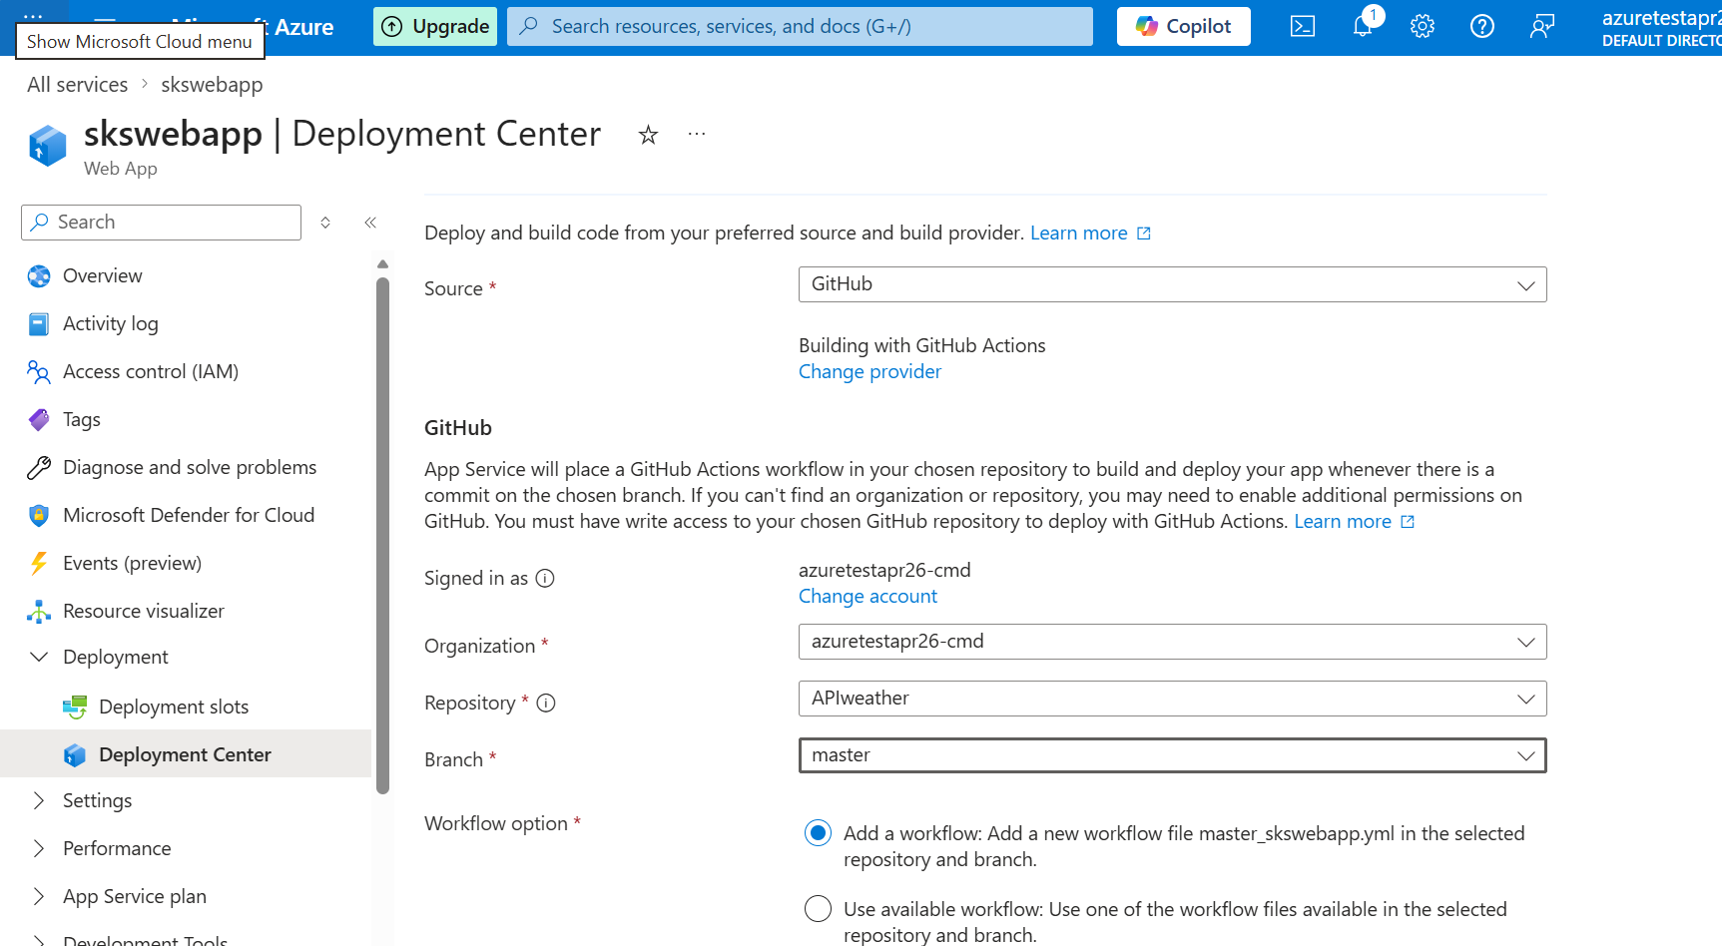

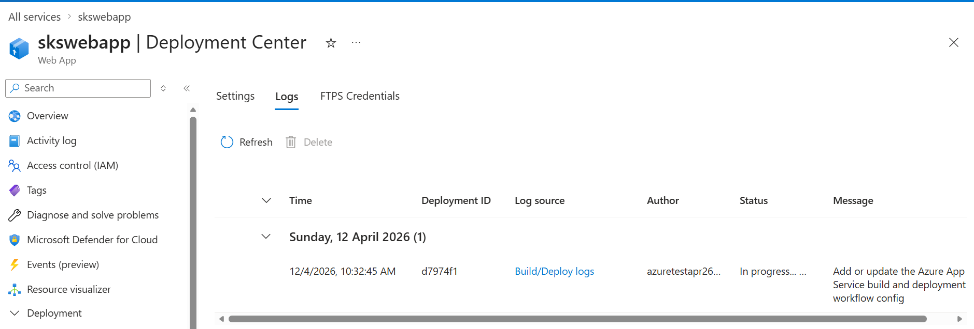

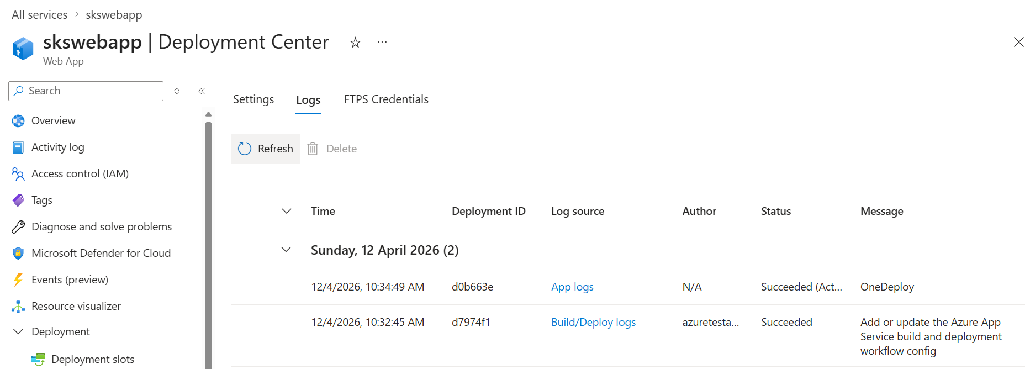

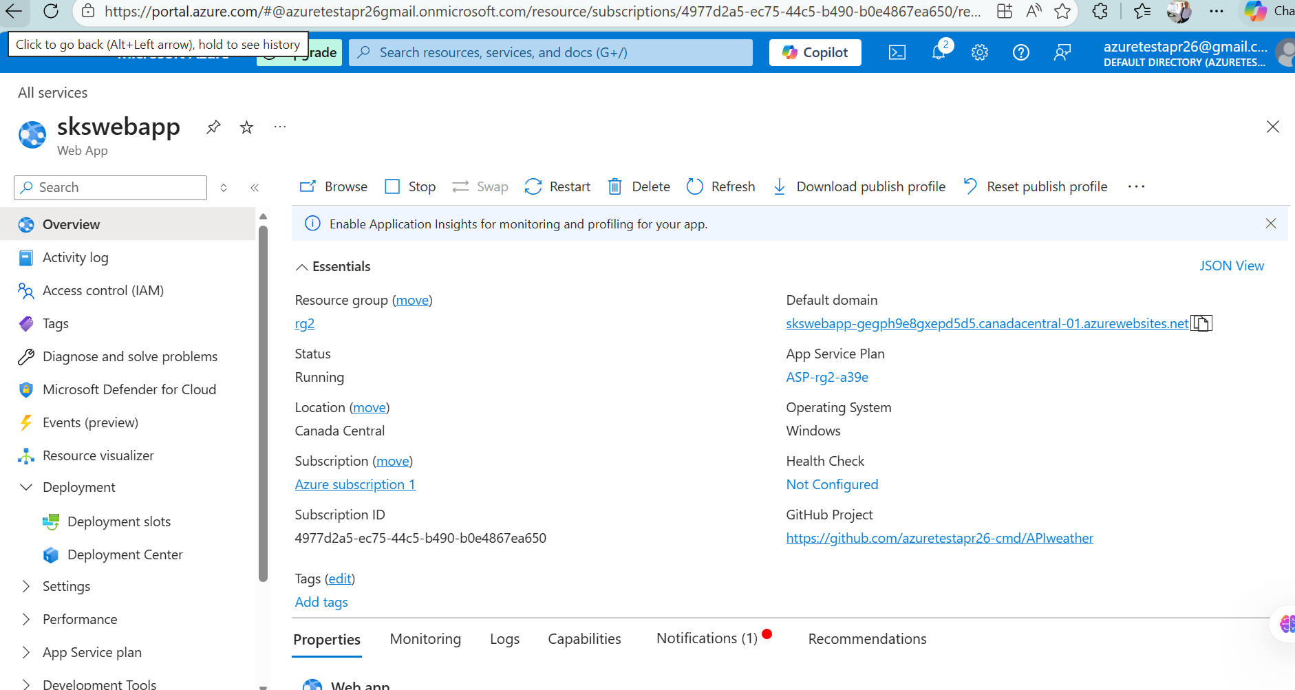

Run using default domain URL
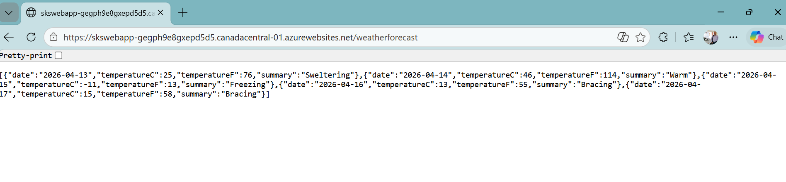

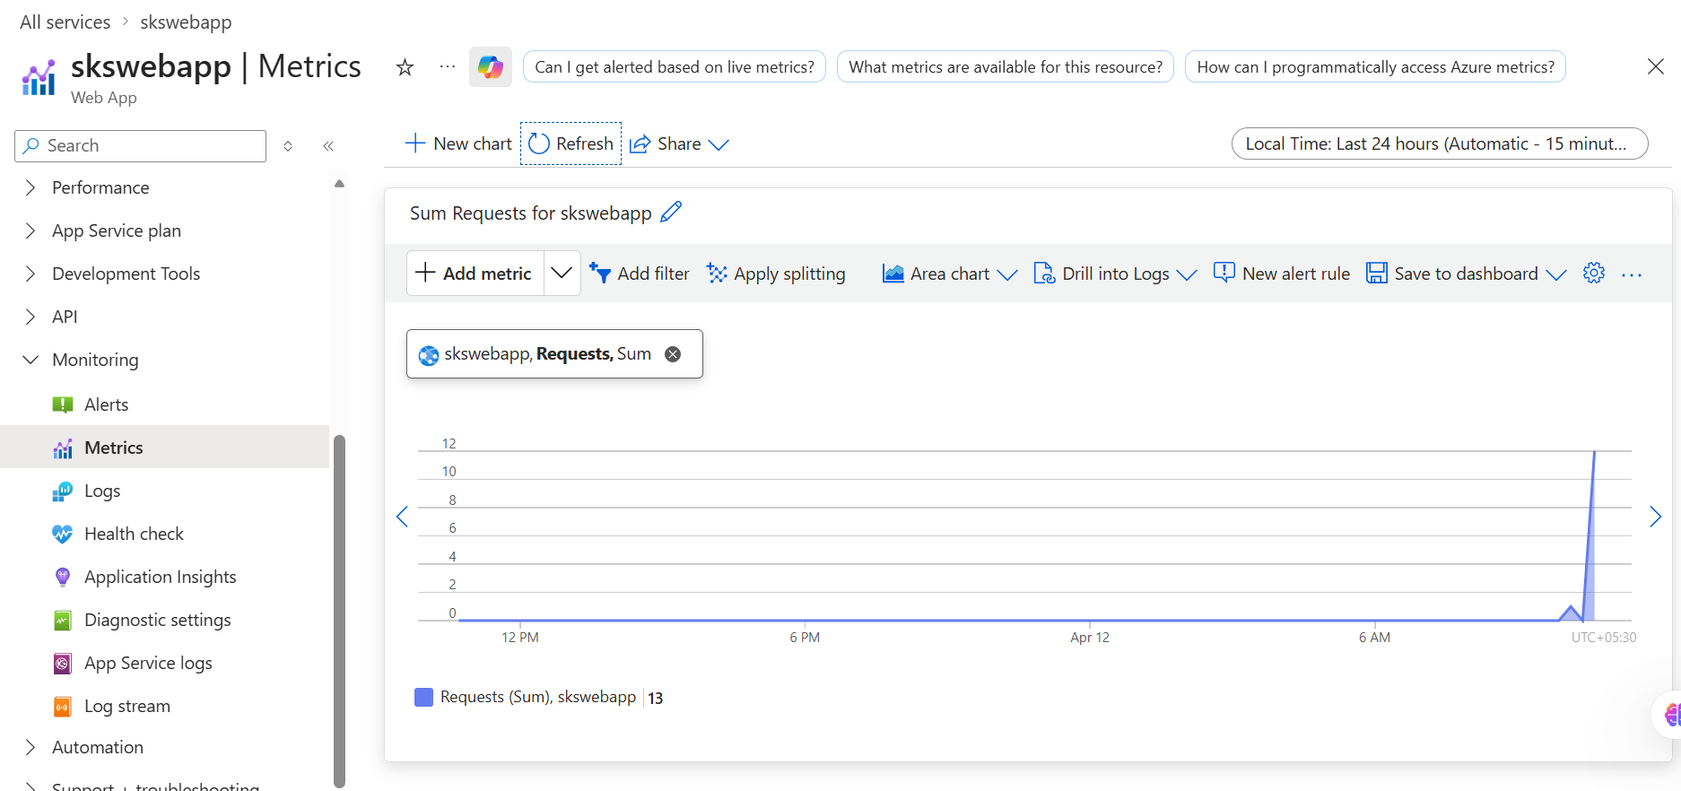

🔶 PART 4: Configuration
Application Settings
- Go to Settings → Environment Variables
- Add:
NAME = Azure Demo
👉 Teaching point:
- Environment variables replace config files
- Secure & environment-specific

Connection Strings (optional)
- Show section for DB integration

🔶 PART 5: Scaling
Scale Up (Vertical)
- Go to Scale Up
- Change:
  - B1 → S1
👉 Teaching point:
- More CPU/RAM

Scale Out (Horizontal)
- Go to Scale Out
- Instances: 1 → 2
👉 Teaching point:
- Load balancing automatic

🔶 PART 6: Monitoring
Enable Logs
- Go to Monitoring → App Service Logs
- Enable:
  - Application logging
  - Web server logging

Metrics
- Go to Metrics
- Show:
  - Requests
  - CPU
  - Memory

Deploy MVC app to Azure

Create MVC app –
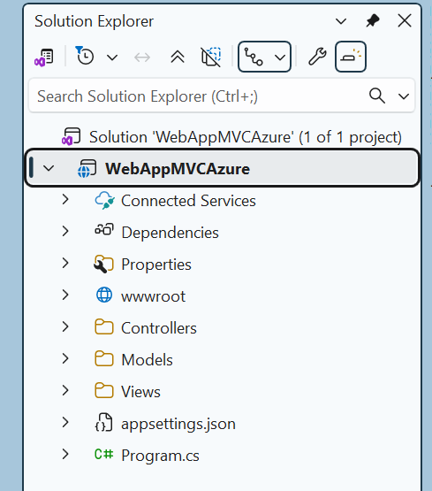

Add to source control –
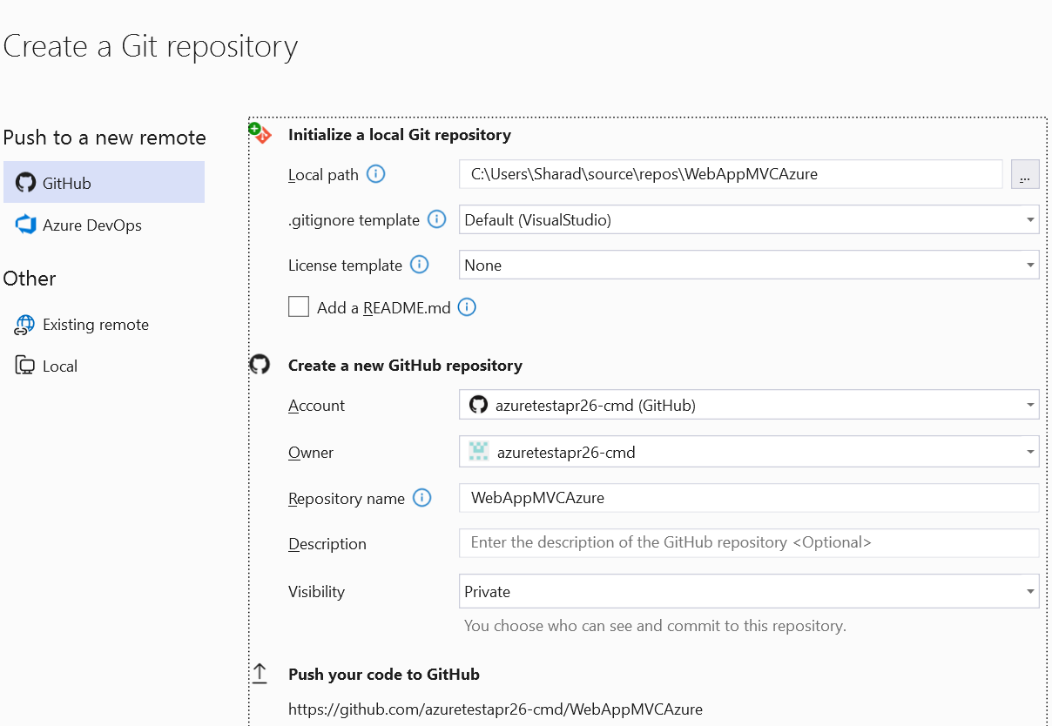

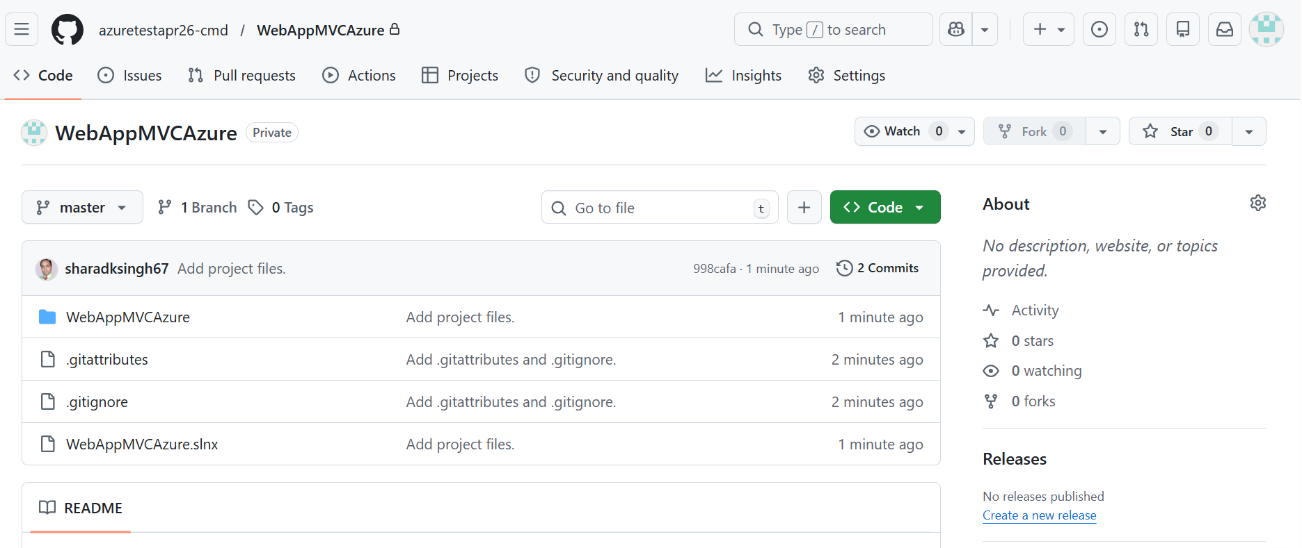

Azure App services – Add Web App
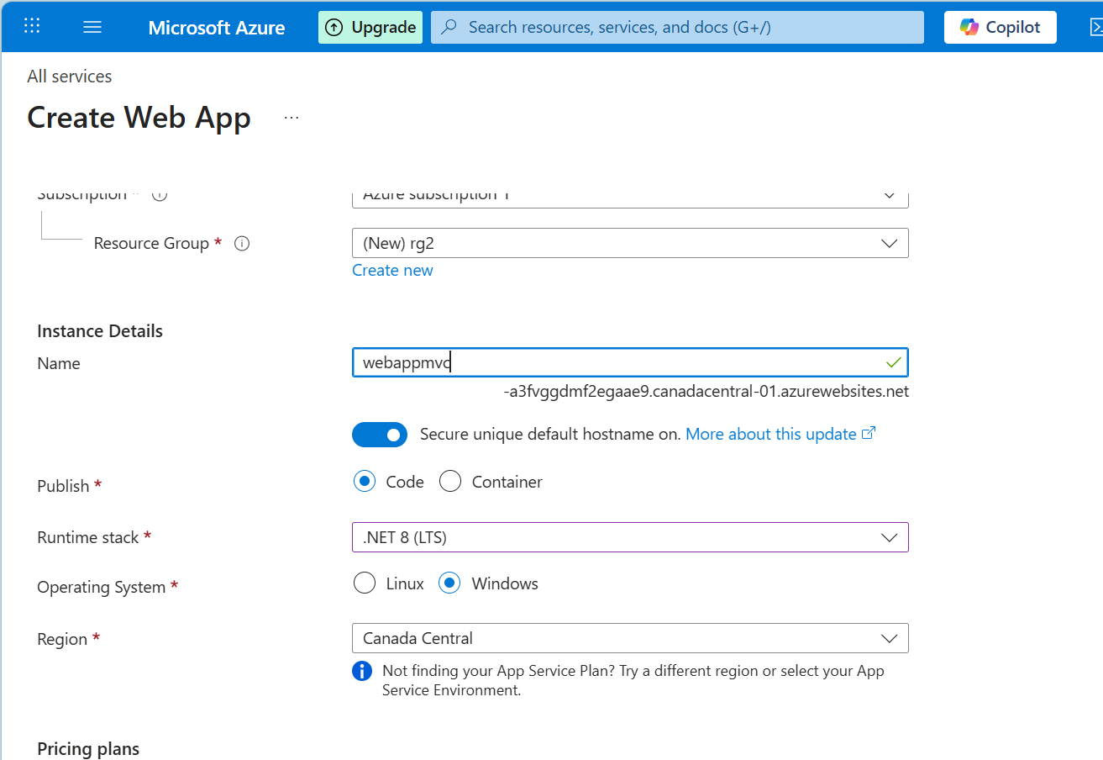

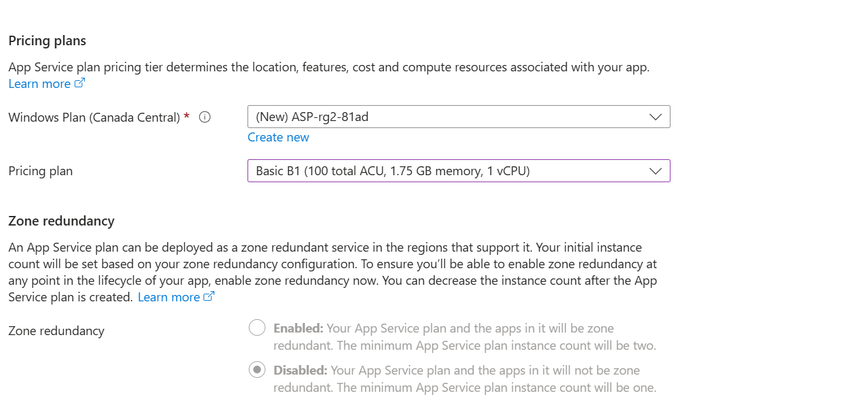

Deployment Center –
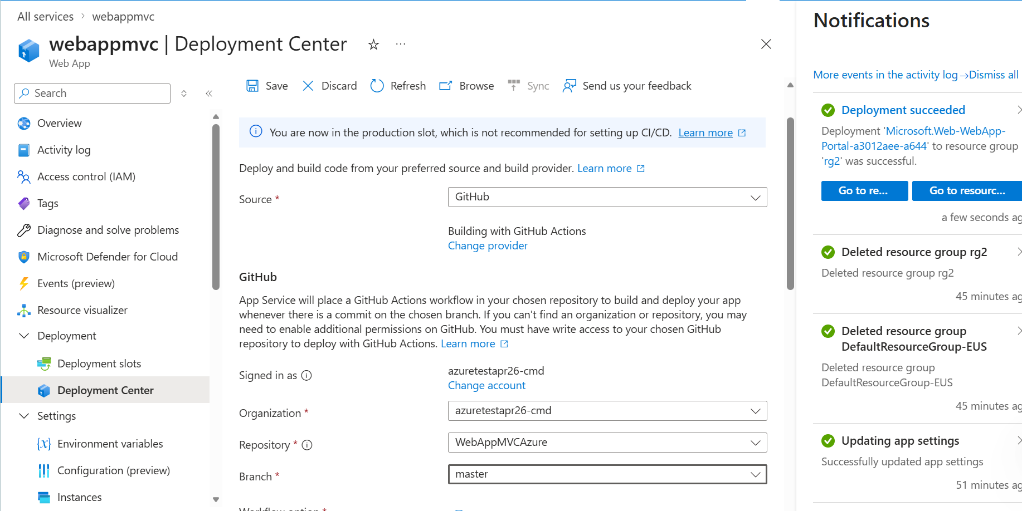

Save – Auto Deployment starts
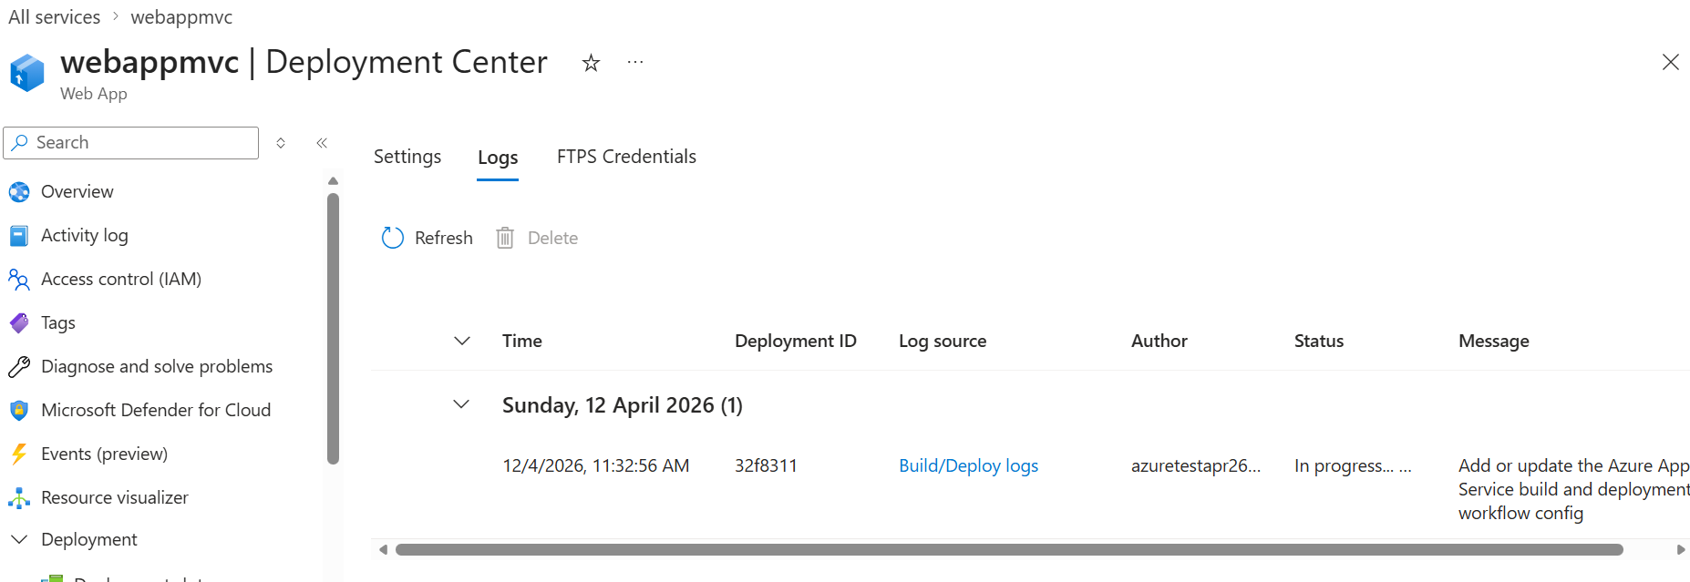

Check public URL
